**Weigh-in Group Application Form** 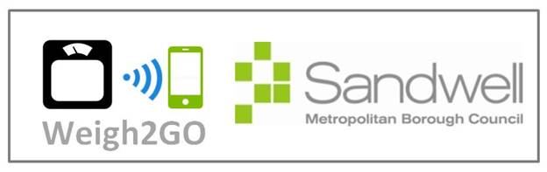

*For Sandwell organisations, community groups and workplaces.*

1. Name of organisation/community group.
2. Organisation’s details including full address and main contact details.
3. Person responsible for W2G including name, email address and telephone/mobile number
4. Why would you like to set up a weigh in group? 50 words max.
5. Who will you be targeting? Age group(s), ethnicities, gender, specialist groups.
6. When would like to start your weigh in group (month/year)? Please bear in mind that you will need training, this may take up to 2 weeks to arrange.

Submit your completed form to [LS@nhs.net](mailto:LS@nhs.net)